An Advertising Campaign Proposal
Name of Author:
Institution:
Date:

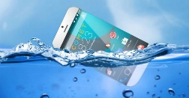
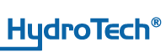
Product: Waterproof Smartphone
Company: Hydrotech Inc.
Campaign: Digital Ad

- Overview
Hydotech is a mobile technology brand that prides on the cutting edge water protective nanotechnology to offer sleek smartphone gadgets that fully provides protection from soda, coffee and water, among other liquids. Our products have been market tested and reflect not only superior quality but also total protection from water and other liquids. Standing on the edge of smartphone technology, waterproof phones offer safety and reliability as consumers have less worry about damage resulting from liquid spill or exposure (Hzodev, 2013: Yu et al., 2019).

- Goals/ Objectives of the ad or campaign
- This ad campaign seeks to raise awareness about our unique brand of waterproof smartphone products with liquid protection as one of its salient features.
- To effectively plan and execute a market campaign that would realize increased demand for the waterproof smartphone product.
- To target a new base of customers who have not heard before and used waterproof smartphone and create our brand visibility.
- To grow the brand loyalty for our smartphone product from the current 5% to 6.5 percent.
- To earn more sales revenue arising from increased demand for the waterproof smartphone product.
- Target audience
The campaign targets persons of all ages who are able to use smartphones in their day to day activities. However, there is more emphasis on three main demographics; teenagers/young adults, the middle-aged persons and older adults. Firstly, the campaign targets teenagers and youth since they are most intensely consumers of digital content and are enthusiastic about latest technological trends (Dienlin and Johannes, 2020). Water protective nanotechnology is an eye-catching innovation to smartphone production, and this feature will mean more safety and lower costs. For instance, typical teenagers/young adults may use this product in their hobbies such as swimming with no consequence on its operationability.
Secondly, the campaign targets middle-aged persons who may not be tech-savvy like youths but have a preference for the cost, convenience and safety of their gadgets. Since they also use their phones all the time, they will no longer be fearful about coffee spills or their phones falling in the water. The use of this product will save this target group from water-related damage or the death of their phones.
Lastly, the campaign targets senior citizens for the reasons of safety of the phones, especially with regard to falling into liquids. While this target population may not be too enthusiastic about the technological trends, they have a preference for safety and convenience (Wang et al., 2019). This product will ensure that contact with liquids will not affect the operations of the phone, and it will be an ideal development or technology for this group.

- The most important thing to say or show & Rationale
For this campaign, the outstanding selling point is that our products defy any challenges regarding water, coffee or liquid spill. The main philosophy is that while other smartphone brands are vulnerable to liquid spills, Hydrotech products are invincible and indifferent in such situation. Therefore, the consumer is assured of a smartphone of a superior brand, having all other exciting features but undamaged by liquids. This marketing mantra is plausible because it marks a unique differentiation of the Hydrotech products from all the rest on the market. The technology used is a first, and consumers are assured safety and operationability for the smartphones against exposure to liquids or humid conditions. The campaign ad thus invites potential consumers to purchase and experience this unique, revolutionary product that beats all odds. The campaign thus communicate a sense of pride and uniqueness, appealing to consumers to witness it first-hand.

- Brand’s values and market positioning
At Hydotech, we have four core values upheld by our brand; Safety, style, simplicity and comfort. We put forth a unique product, utilizing cutting edge technology to support safety and comfort for the consumers. The product represents market tested safety (against liquid exposure) as well as offering comfort and unique identity in consuming this product. The production teams at Hydrotech were dedicated to developing a product that would solve the problems of unreliability and safety in the use of mobile phones. In addition to a myriad of features that a typical smartphone has, our product goes a notch higher to guarantee safety, style and comfort. These values reflect our market positioning as a brand that provides solutions while giving consumers a special style in this unique product. At Hydotech, it is not just enough to be different, but being different with style, comfort and safety for the smartphone gadget that one uses.

- Creative team role
The main goal for the creative team is to plan and implement a marketing program that is highly convincing to consumers and reflects the unique values embedded in the use of our brand. The ream should present our waterproof smartphone technology as an attention-grabbing idea that has come to reality. This idea should be the emphasis as a distinguishing factor from other brands that do not have this unique technology. The team, therefore, has to create ‘wow’ moments among the consumers and persuade them that such unique experience is now a reality that one can enjoy at an affordable price.
- Communication channels used
This will be a digital campaign and it would utilize various sources of digital platforms. For instance, the ad will run on YouTube, Instagram, twitter, Snapchat and Facebook in form of a video ad. The ad will also utilize conventional media platform such as television as well as radio for it audio version. The diversity of communication channels will be fundamental to widen its reach and engagement among the target audiences.

- Campaign or ad schedule
First, the planning of the ad will take about three weeks where the creative team will plan out every last detail of how the ad will appear on the communication platforms. The next two week will be devoted to gathering the resources and logistical aspects needed to execute the campaign. This would include the choice of models, venue, props and other on-site requirements. Then, the following one week will be devoted to shooting the advert. Finally, post-production editing and refining will be undertaken in the next couple of weeks. At the end of the eight week period, the ad will be ready to run across the various communication channels. The running time is estimated to take up to four and a half months. The summary is given below:

Activity | Estimated Time
Planning phase for the ad | 3 weeks
Gathering Resources & logistics | 2 weeks
Shooting of the ad | 1 week
Post-production editing & refining | 2 weeks
Presenting the ad ready for running | Start of week 9
Estimated time for running the ad | 4.5 months

- Supplemental Materials with Example
The company will invest in other supplemental materials to drive the camping and ensure more engagement with the potential consumers. For instance, print media artefacts such as flyers, banners, and billboards will supplement the marketing efforts. These will be placed in strategic places to further improve brand awareness. In addition to that, the company will attach branded materials such tee-shirts, branded coffee mugs or smartphone covers to supplement the marketing message as well as boost the enthusiasm for more purchases. For instance, the purchase of two Hydrotech products will make a consumer eligible for either a branded tee-shirt or coffee mug. These supplemental materials will boost awareness and engagement. A typical branded tee-shirt is shown below:
Figure 1: Branded tee-shirt as supplemental material
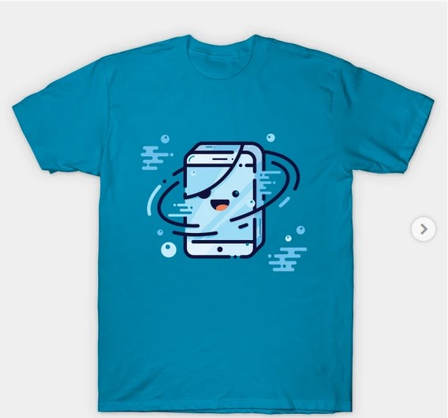

References
Dienlin, T., & Johannes, N. (2020). The impact of digital technology use on adolescent well-being . Dialogues in clinical neuroscience, 22(2), 135–142. Doi: 10.31887/DCNS.2020.22.2/tdienlin
Hzodev (2013). Waterproof Smartphones – The Next Step in Gadget Evolution. Retrieved on 29 May 2021 from https://www.hzo.com/blog/waterproof-smartphones-step-gadget-evolution/
Yu, Q., Xiong, R., Li, C., & Pecht, M. G. (2019). Water-resistant Smartphone Technologies. IEEE Access, 1–11. Doi:10.1109/access.2019.2904654
Wang, S., Bolling, K., Mao, W., Reichstadt, J., Jeste, D., Kim, H. C., & Nebeker, C. (2019). Technology to Support Aging in Place: Older Adults' Perspectives. Healthcare (Basel, Switzerland), 7(2), 60. Doi: 10.3390/healthcare7020060

